Understanding the Different Types of Dental Radiographs at Crystal Radiology. (02) 8315 8292

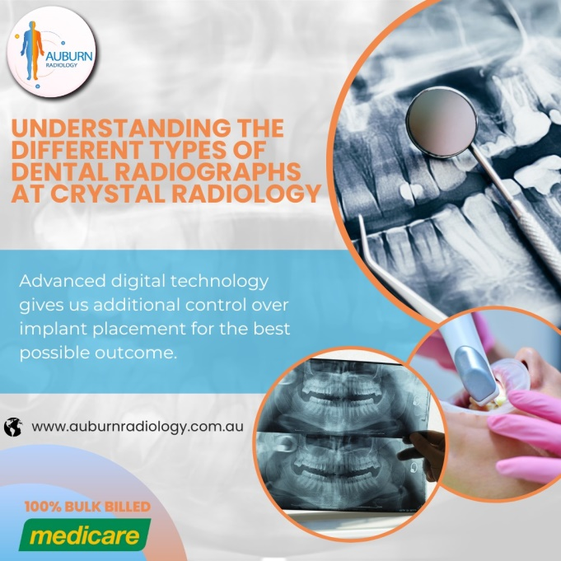When you visit the dentist for a routine check-up or specific dental concerns, dental radiographs, commonly known as X-rays, are often taken to assist in diagnosing issues that may be hidden from the naked eye. X-rays allow your dentist to see beyond the visible surface of your teeth and gums, offering a more comprehensive view of your oral health. Through the use of different types of X-rays, dentists can detect early signs of decay, assess tooth eruption in children, diagnose infections, and plan for treatments.

In this article, we will explore the various types of [dental X-rays](https://crystalradiology.com.au/dental-cbct/), their specific uses, and how they contribute to maintaining and restoring your oral health.

### Are Dental X-rays Safe?

Yes! Dental X-rays are considered safe, and several precautions are taken to protect both patients and dental staff during the process. Modern dental X-ray machines use low levels of radiation, and the exposure time is brief. Dentists only recommend X-rays when absolutely necessary, and protective measures, such as lead aprons and thyroid collars, are often used to minimize radiation exposure to surrounding areas of the body.

Routine X-rays, such as bitewing [X-rays](https://crystalradiology.com.au/dental-cbct/) and orthopantomograms (OPGs), are usually taken every two years, unless a specific issue requires more frequent imaging. By following these safety protocols, patients can feel assured that dental X-rays are an effective, safe tool for assessing oral health.

### Types of Dental Radiographs

There are two primary categories of dental X-rays used in dentistry: [**intraoral**](http://crystalradiology.com.au/dental-xray-opg/) (taken inside the mouth) and **extraoral** (taken outside the mouth). Each type of X-ray serves a unique purpose and helps the dentist gain valuable information for different aspects of your dental care.

### Intraoral X-rays

**Intraoral X-rays** provide detailed images of the teeth, roots, and surrounding bone structure. They are typically used to detect cavities, check the health of tooth roots, and examine the bone levels around teeth. These X-rays are also used during procedures like root canals or when investigating infections or trauma. The three most common types of intraoral X-rays include:

1. **Bitewing X-rays** Bitewing X-rays are commonly used during routine dental check-ups. They allow the dentist to examine the **upper and lower teeth simultaneously**, focusing on the molars and premolars. This type of [X-ray](http://crystalradiology.com.au/dental-xray-opg/) is especially useful for detecting decay between the teeth, which may not be visible during a regular oral examination. Since bitewing X-rays capture the area between the teeth, they help the dentist identify early-stage cavities that can be addressed before they worsen.
2. **Periapical X-rays** Periapical X-rays capture a **detailed image of one or two specific teeth**, including the crown, root, and surrounding bone. This type of X-ray is commonly used when there is a suspicion of infection at the tooth's root or when there are symptoms of a potential abscess. During procedures like root canals, periapical X-rays provide critical information about the condition of the root and the supporting bone.
3. **Occlusal X-rays** Though less commonly used, occlusal X-rays capture the **entire arch of the upper or lower teeth** in a single image. They are particularly helpful in identifying abnormalities related to tooth development, such as impacted teeth, extra teeth, or tumors in the mouth.

### Extraoral X-rays

**Extraoral X-rays**, on the other hand, provide a broader view of the teeth, jaw, and skull. These are typically used for diagnosing larger issues related to jaw development, bone structure, and orthodontic planning. Some common types of extraoral X-rays include:

1. **Orthopantomogram (OPG)** An [**OPG**](http://crystalradiology.com.au/dental-xray-opg/) is a **panoramic X-ray** that provides a complete image of the entire jaw, including all the teeth, upper and lower jawbones, and surrounding structures. This type of X-ray is frequently used to assess tooth development, especially in children, as well as to check for problems such as impacted wisdom teeth, fractures, or cysts in the jawbone. It’s also useful for evaluating the overall bone levels in patients with periodontal disease.
2. **Cephalometric X-rays** Cephalometric X-rays capture the **entire side of the head**, offering a detailed look at the relationship between the teeth, jaw, and facial structure. These images are primarily used for **orthodontic planning**. Dentists or orthodontists can analyze the alignment of the jaw and teeth, which helps them develop treatment plans for correcting misalignments or planning for braces.
3. **Cone-Beam Computed Tomography (CBCT)** Cone-beam computed tomography, or [**CBCT**](https://crystalradiology.com.au/dental-cbct/), is a specialized type of X-ray that produces **3D images** of the teeth, jaw, and surrounding structures. This technology is commonly used for **dental implant planning** and **complex surgeries**. It allows dentists and oral surgeons to evaluate bone density, measure the exact location of nerves, and determine the ideal placement for implants. CBCT scans are also invaluable in diagnosing conditions like temporomandibular joint (TMJ) disorders.

### Why Are Dental X-rays Important?

Dental X-rays are critical in identifying potential dental problems before they become severe. While visual examinations are essential[, X-rays](https://crystalradiology.com.au/dental-cbct/) provide a more detailed view of areas that are difficult or impossible to see with the naked eye. Detecting issues such as cavities between teeth, infections, bone loss, and impacted teeth early on can lead to better outcomes, less invasive treatments, and reduced costs in the long run.

X-rays are also used to monitor ongoing dental health. For example, patients undergoing orthodontic treatment will require regular X-rays to assess how their teeth are shifting. Similarly, patients with a history of periodontal disease or dental implants will need periodic X-rays to check for bone health and implant stability.

### Why Choose Crystal Radiology?

We are local and a privately-owned medical clinics that offers the highest quality medical and Imaging Services in the [Crystal radiology](https://crystalradiology.com.au/appointment/) region. We are the leaders in Bulk Billing with the real benefit of no ‘Out of Pocket’ expenses for you.

### Your Next Step

Please ensure that you have your Medicare card and referral with you and pop into our location for your consultation. If you have any questions at all, please feel free to contact us at [(02) 8315 8292](https://crystalradiology.com.au/appointment/) as we are here to help.